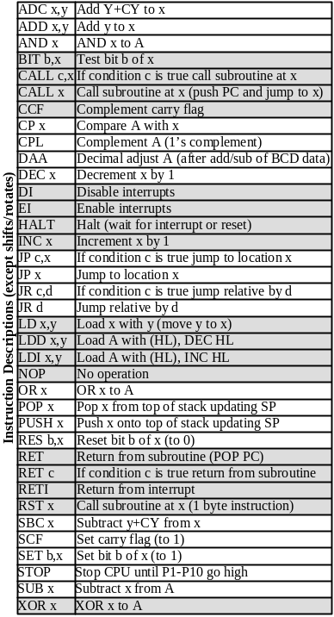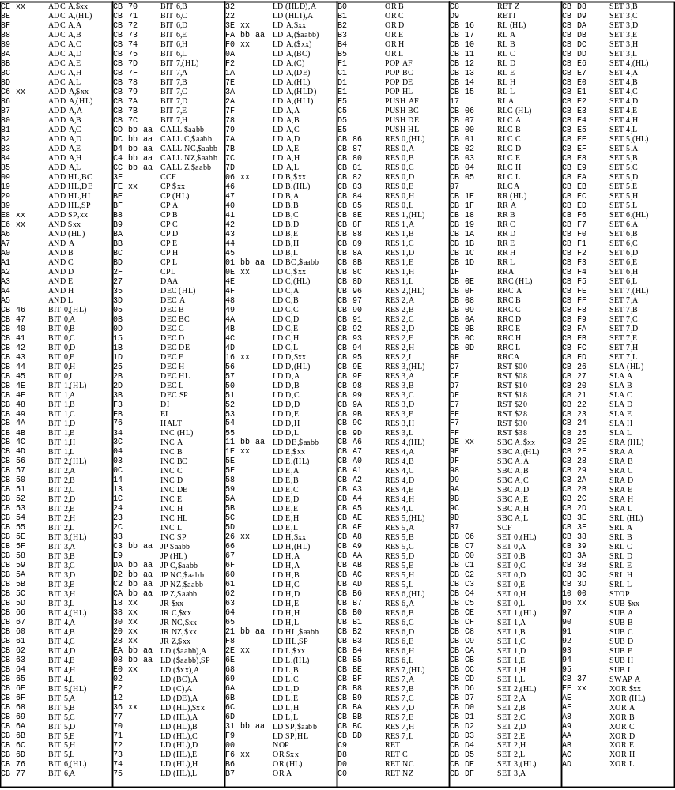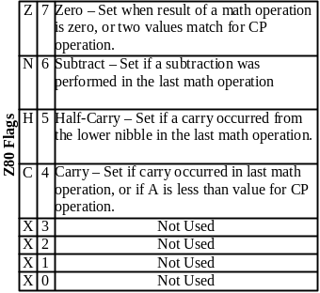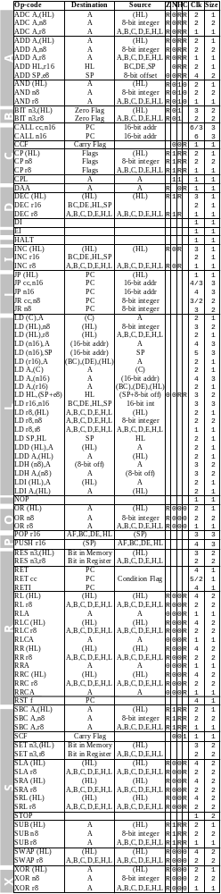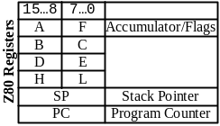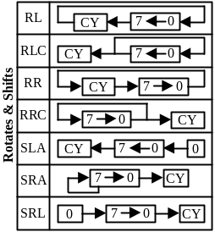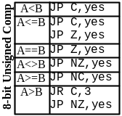

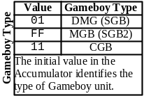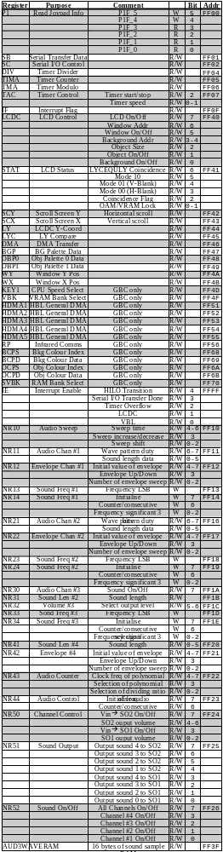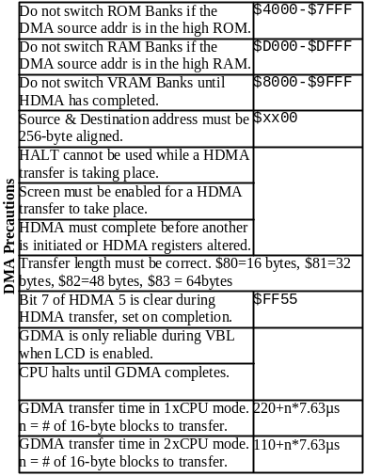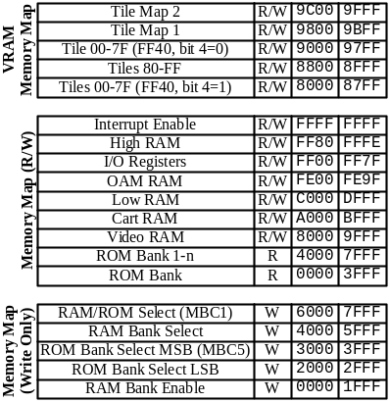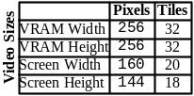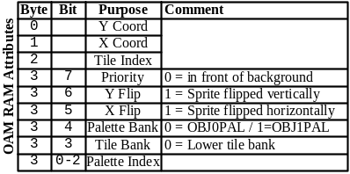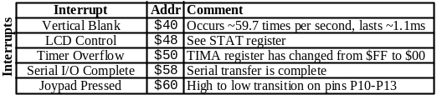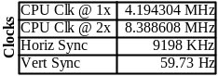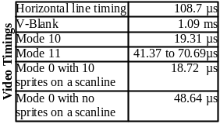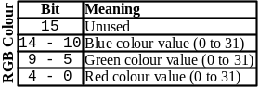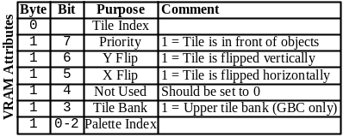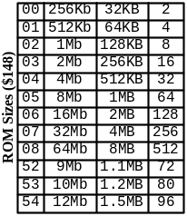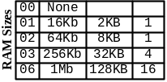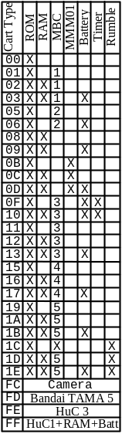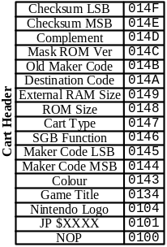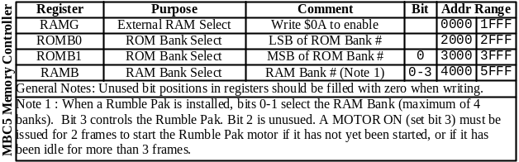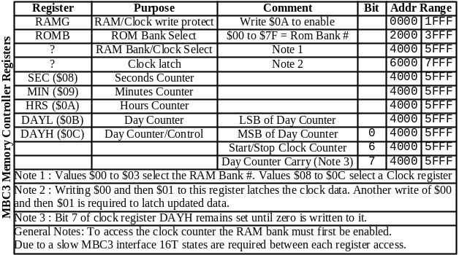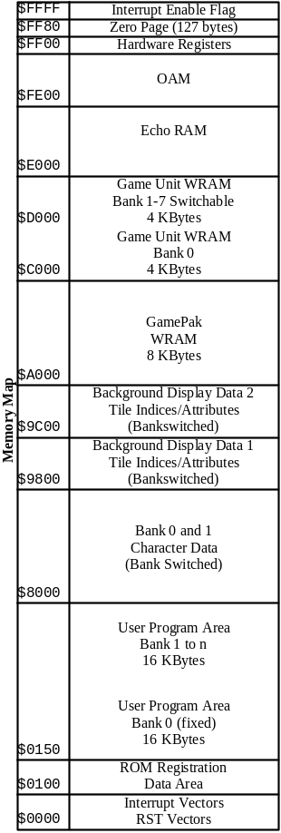
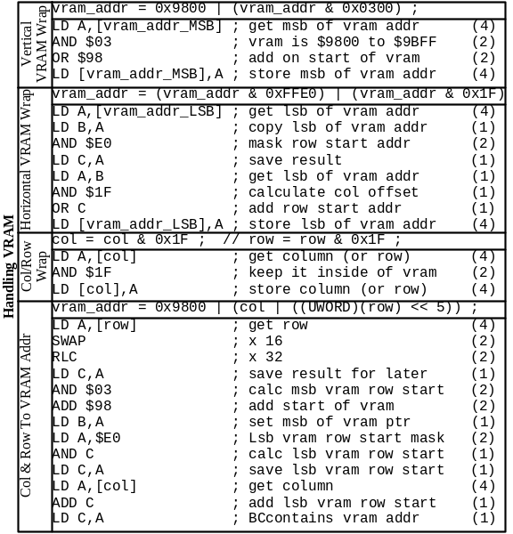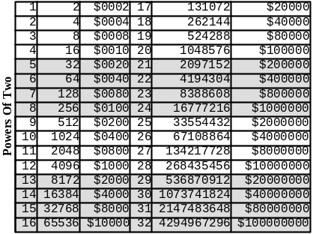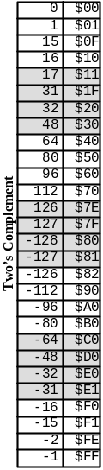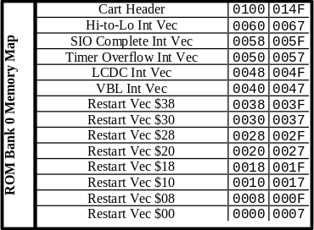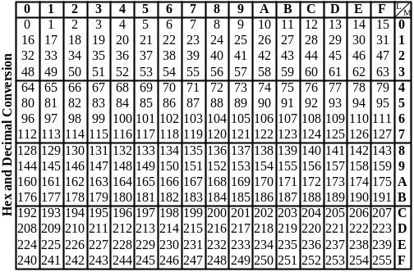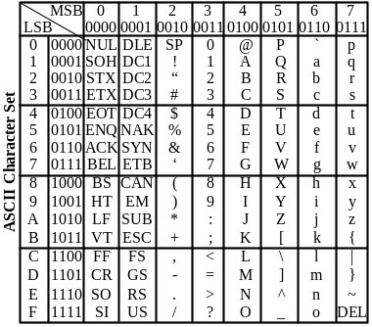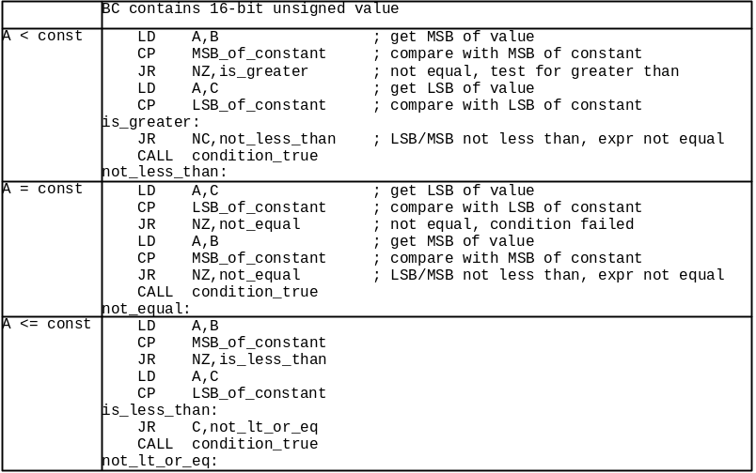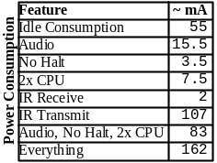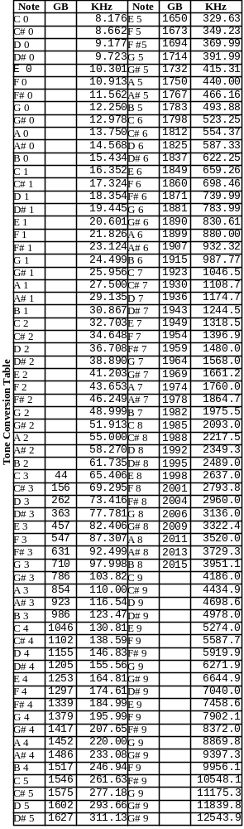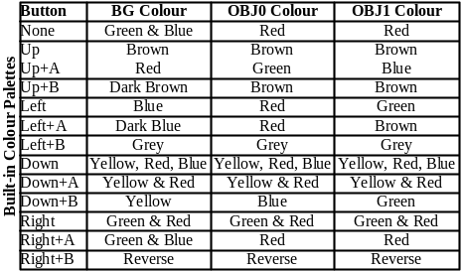

Gameboy Crib Sheet contains:
List of Gameboy Z80 op-codes with timings, sizes
Z80 registers & flags
Visual description of shift & rotate operations
Code for 8-bit unsigned compares
Two’s complement table
Powers of two table
Hex to Decimal/Decimal to Hex conversion table
ASCII character set
Gameboy interrupts
Complete list of all known Gameboy registers
Code for handling VRAM
Cartridge header information, including RAM Sizes, all known ROM sizes up to 64MBit, all MBC types and features
Video timings
Miscellaneous Gameboy timings
Memory Map
OAM RAM ordering (v0.7)
MBC3 registers (v0.8)
MBC5/Rumble Pak registers (v0.8)
Power consumption (v0.8)
RGB colour format (v0.9)
Attribute fields for VRAM Tiles (v0.9)
Sound tone tables (v0.9)
Complete Gameboy Z80 variant op-code list with hex values (v1.0) new
Built-in colour palette combinations (v1.0) new
Gameboy unit identification (v1.0) new
Memory map (v1.0) new

Things to add:
Z80 code for 16-bit unsigned/signed compare operations
Z80 code for 8-bit signed compare operations
Meaning of GB/DMG/GBC flags at $143
List of all known manufacturers.

List of known bugs:
External RAM Size Table is probably incorrect.
Explanation of 0x146 is probably incorrect.
Explanation of 0x143 needs to be clarified.

Use:
The Gameboy Crib Sheet is designed specifically for printing on a high quality laser or inkjet printer. The Crib Sheet is not designed to be viewed on-screen.

To obtain the best results from printing make sure you use the best quality paper you can obtain that has minimum bleeding. The “High Gloss” is usually the best choice but you must be sure to remove the sheet from the printer the moment it has finished printing and allow it to dry for several minutes to prevent smudging.

Notes:
It is only available in Adobe PDF format and will probably never be converted to HTML, so don’t ask.

Undocumented features
Sprite bugs
Value at $143 is $80 = GBC compatible game

Value at $143 is $C0 = GBC dedicated game
All other values at $143 indicate a regular GB game.

The ram size does not comply with the one from Nintendo as far as I can see.
From Nintendo CGB User's Guide:
External RAM Size (0149H)
Store the code for the size of external RAM installed in the cartridge.
Address 149 RAM Size
00H No RAM or MBC2
01H -------
02H 64 KBit
03H 256 KBit
04H 1 Mbit
You write that 0146 is Game Unit Code: Nintendo says:
Store the Function Code for the game program. Use the table below.
0146H Super Game Boy Function
00H Game Boy (will also run on Super Game Boy)
03H Uses Super Game Boy Functions
CGB Compatibility Code (0143H)
Store the code which distinguishes between games that are CGB (Game Boy
Color) compatible, and those that are not.
Address 143H Denotation
00H CGB Incompatible
80H CGB Compatible
C0H CGB Exclusive
CGB Incompatible: A program which does not use CGB functions, but operates
with both CGB and DMG (Monochrome).
CGB Compatible: A program which uses CGB functions, and operates with both
CGB and DMG.
CGB Exclusive: A program which uses CGB functions, but will only operate
on a Game Boy Color unit (not on DMG/MGB). If a user attempts to play this
software on Game Boy, a screen must be displayed telling the user that the
game must be played on Game Boy Color.
Extra info from Nintendo's doc:
Game Code (013FH~0142H)
Please enter the 4 character Game Code in hexadecimal format which has
been assigned to your software title by NOA.
For example,
If the Game Code is "APCJ",
Address 013FH = 41H ('A')
Address 0140H = 50H ('P')
Address 0141H = 43H ('C')
Address 0142H = 4AH ('J')
This requirement only applies to new titles. If the program is changed and
a master ROM resubmitted for a game title which has already been marketed,
it is not necessary to insert a game code for this submission. (If the Game
Code is added to an existing game, please be aware of potential problems
with software verification routines in serial communication protocols or GB
Pak routines. For example, the Game Titles for the old version and the new
version MAY be different, causing the new version to be unrecognized by the
software verification routine.)

